**Billing and payment:**

**CUSTOMER**:

1. 2 customer groups: Registered and New customer.
2. Both can:

* Review item before payment.
* Report an issue with the bill.
* Update address and contact information for every bill.
* Rate/give feedback about the food, service, etc.
* Have many payment options: cash, card, online banking.

1. Registered customers can:

* Be promoted with promotion.
* Save address and contact information for future use.
* Earn points based on the bill an make payment with points.

**CLERK**:

1. Handle modify/cancel requests from customers.
2. Print the bill.

**SYSTEM:**

1. Store bills.

**USE CASE DIAGRAM:**

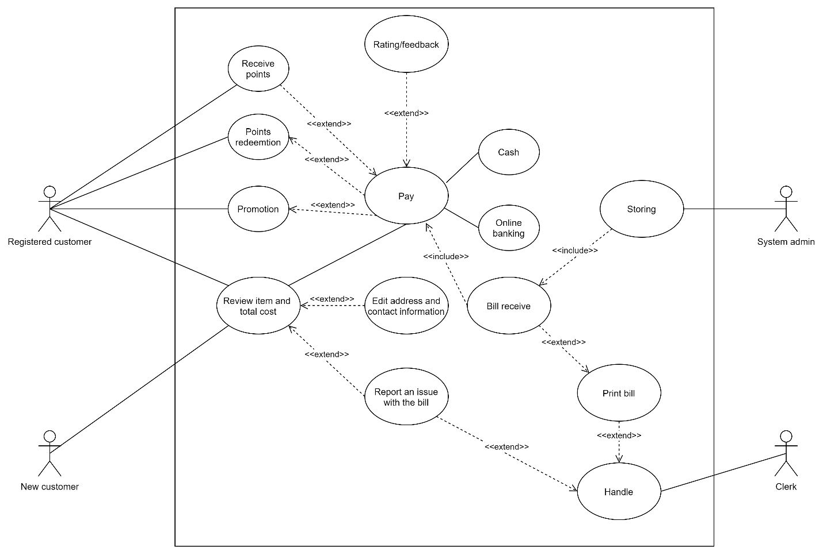

**FORMAT TABLE:**

| Use-case name | Billing and payment |
| --- | --- |
| Actor | Registered customer, New customer, Clerk, System |
| Description | Customer reviews item list and makes payment. |
| Preconditions | The Internet is available, Website is available, Customer has finished ordering. |
| Flow | 1. When the customer has finished ordering food. 2. Customer reviews item list. 3. If the customer is registered, they might be promoted with promotion. 4. Customer chooses a payment method. 5. If the customer is registered, they can choose to pay with reward points. 6. Customer is asked to check address and contact information one last time. 7. Customer makes payment. 8. Customer rates/gives feedback. 9. Customers receive reward points. 10. Customer receives a bill. 11. Clerk prints the bill if the customer is at the table. 12. System stores the bill. |
| Exceptions: | 1. In case of take away, if the customer hasn’t filled in information like address, phone number, … System will alert that “Please fill in all required fields”. 2. If the cart is empty or there is no item in progress of purchasing, the system will alert that “Please select at least one item”. |